Login/ Sign up -> student, admin
Demo link:

Login/ Sign up
Student:
- Name
- Email college and personal (both needs to be verify using otp and can be updated also in future).
- Phone Number.
- Resume.
- Roll Number.
- Branch
- 10th, 12th, current marksheet with gpa calculated.
Admin:
- Name.
- Official College Email.
- Phon Number.

Login Page:
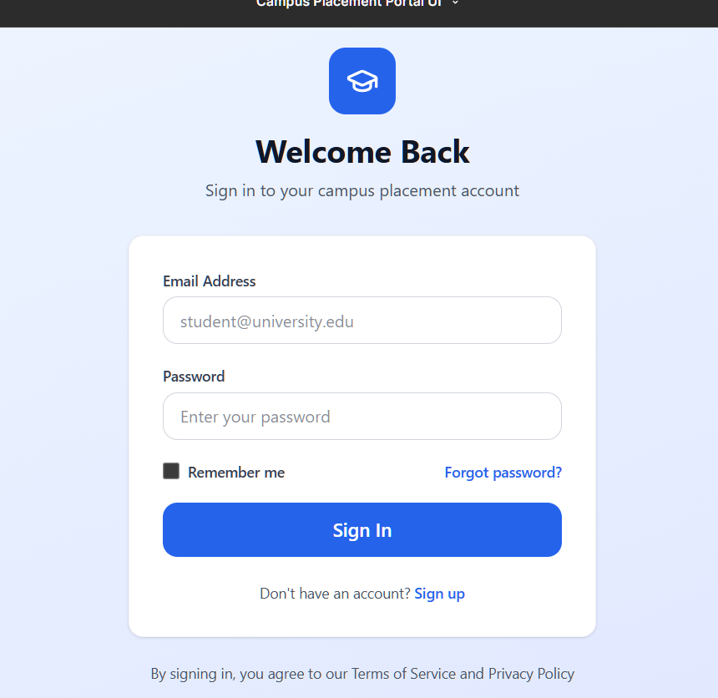

Admin Login Successful:
Admin login to control the job openings for the college student. And add the eligibility criteria for the student for different companies.

Create Job opening.
- Company.
- Job Profile (there can be multiple job profile so the admin can add all of those at once but from the student side he can select the check box according to his eligibility).
- Package (If multiple Job Profile, then there is a drop-down menu for every job profile).
- Job Description
- Location
- Interview Rounds
- Eligibility criteria
- For which course it is like for B. Tech, M. Tech, MBA.

Student Login Successful:

Pages:
- Dash Board.
- Jobs
- Companies
- Alumni Connect

Dash Board:
- Displays the status of the Jobs applied and the status of each and every round.
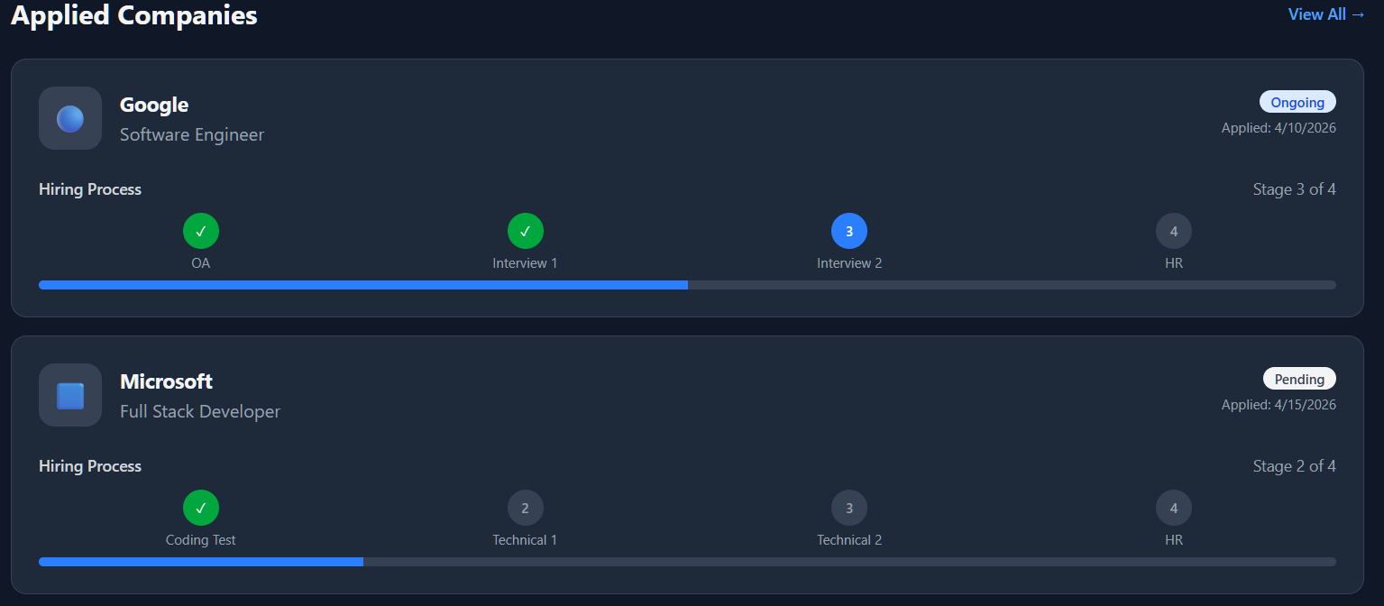
- Filter feature on the basics of package, location, type of Industry, Role.
- Status of Job’s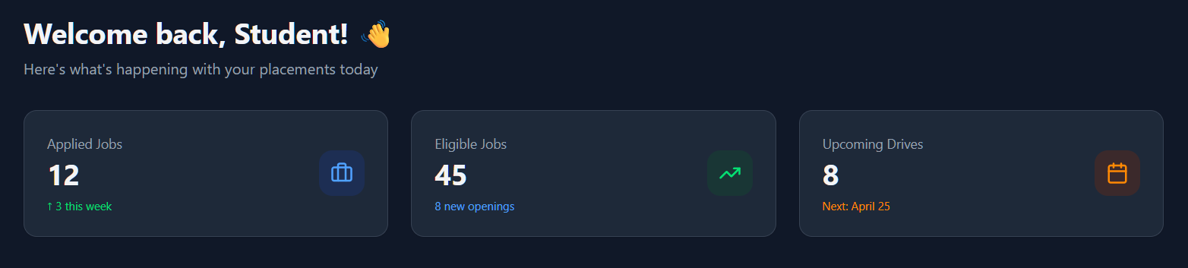

Dash Board Page:
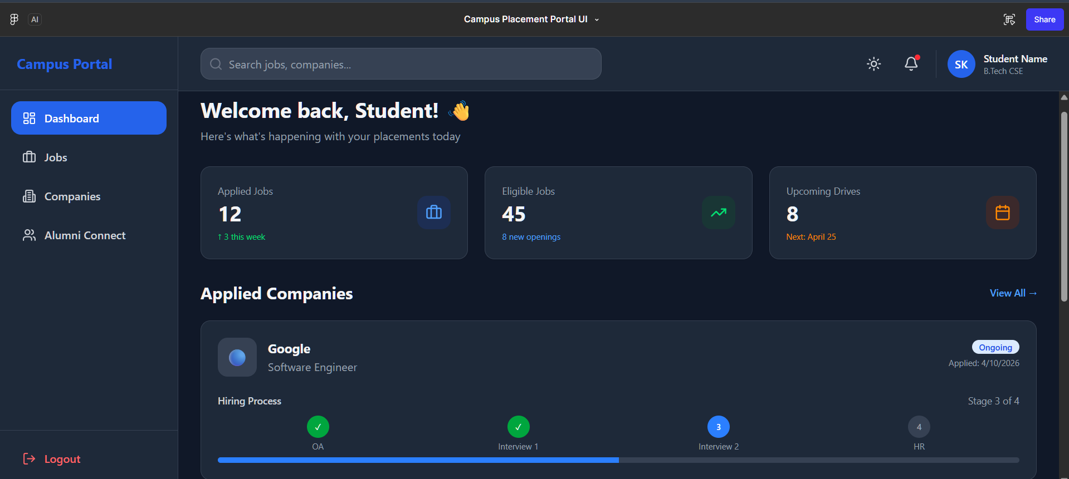

Jobs Page:
- Includes all the Job openings in a form of banner with a apply button functionality.
- First show the Job in which the student is eligible will be prioritized first.
  - Can sort the list of companies on the basics of eligibility criteria as well as pacakage.
- Filter for Job Openings
  - Company
  - Type of Industry (Ed Tech, Finance, Banking, Mass Heiring, Start Up, Big MNC)
  - Job Profile
  - Package of the Company
  - Location
  - Status
    - Open
    - Closed
    - Upcoming
- Job Page
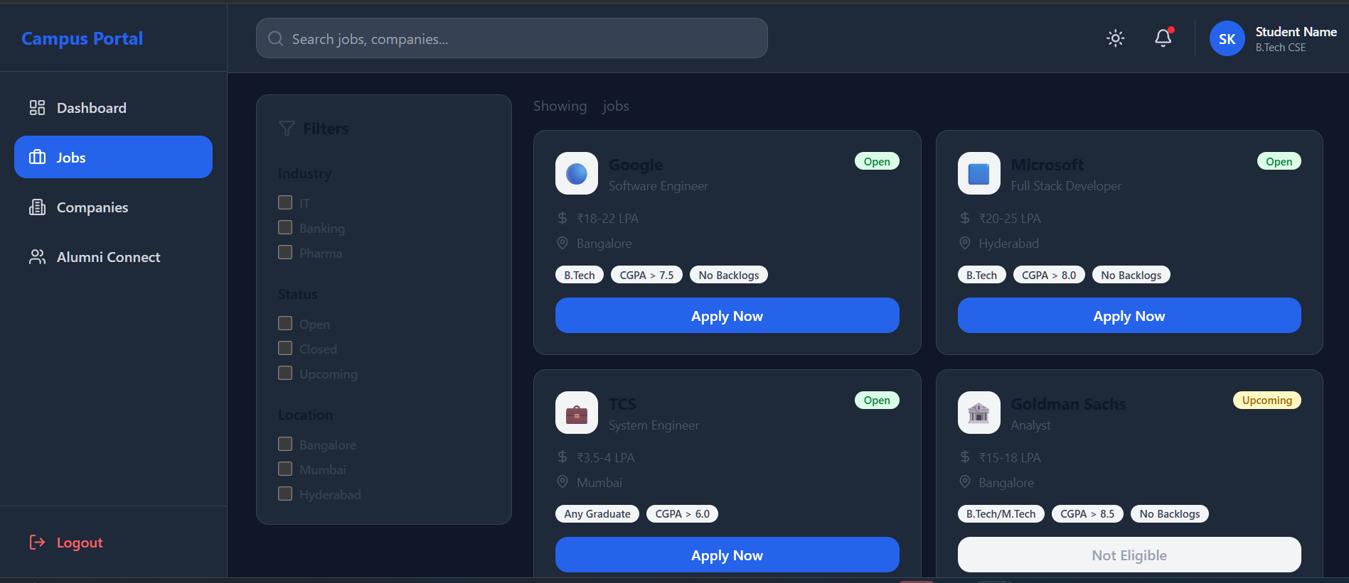

Job Banner:
- After clicking on any Job banner, it displays;
  - Role
  - Package
  - JD (Job Description)
  - Location
  - Interview Rounds
  - Eligibility Criteria
  - Selection criteria
  - Heiring Process
  - Interview Experience
  - Selected Student list -> on clicking student can communicate to that senior.
- Apply feature it automatically sends all the details of the student to the company or the admin portal whatever want.

Apply Button
- Apply Button should be enabled only if the student is eligible for that particular Job.

Detail Job Banner:
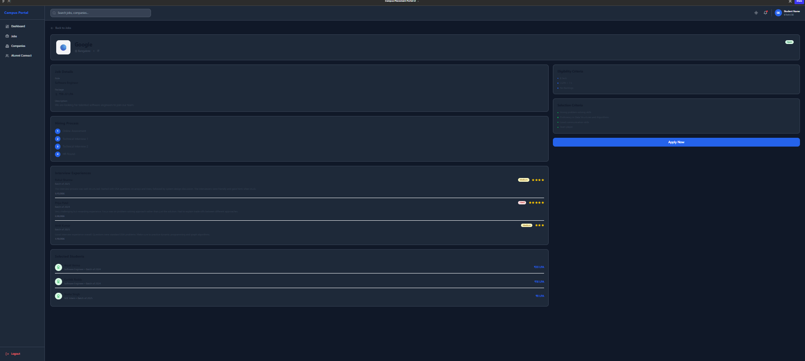

Companies Page:
- Main agenda of this page is to display all the companies visited to the campus
- Interview experiences
- Get a change to get help from the already shortlisted students in that particular company
- What was the heiring process previously of that company when it was visited in the campus and what package they offer previously
- To maintain the record for the admin to track the placement of the students
- Filter feature
  - Industry type of the company.
  - Location
  - Package offered
  - Job Profile
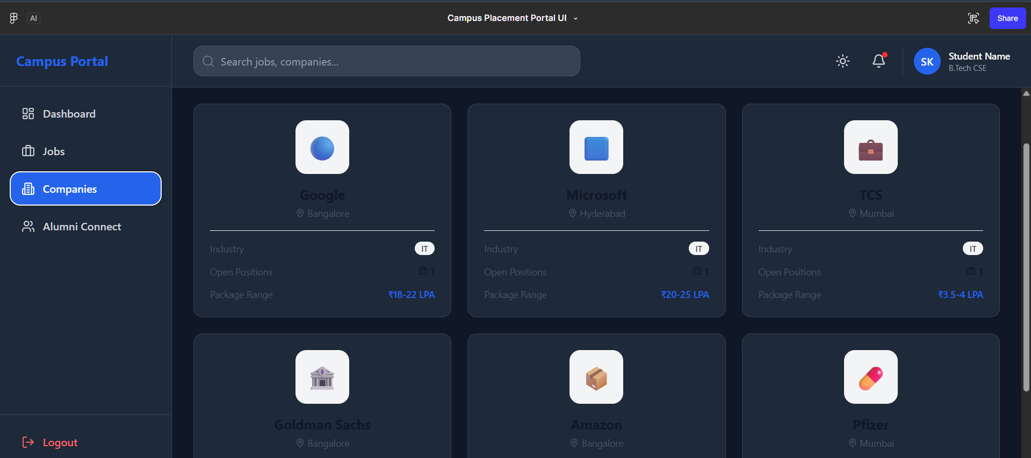

Company Banner:
- Displays all the detail info about the
  - Company: Role, Package, JD.
- Eligibility Criteria
- Selection Criteria
- Heiring Process
- Interview Experiences
- And Most Important previously selected student from the college
  - So that the students ask for help from the already selected senior in the company and may ask for referral in the company using our Alumni connect portal.
- List of previously selected student sorted on the basics of latest selected student in the company.
- 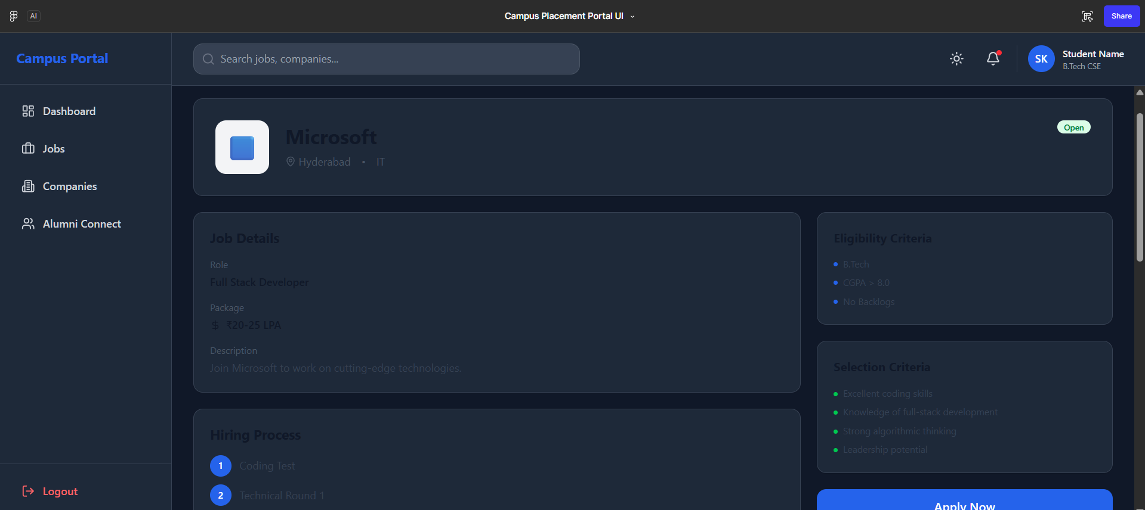
- 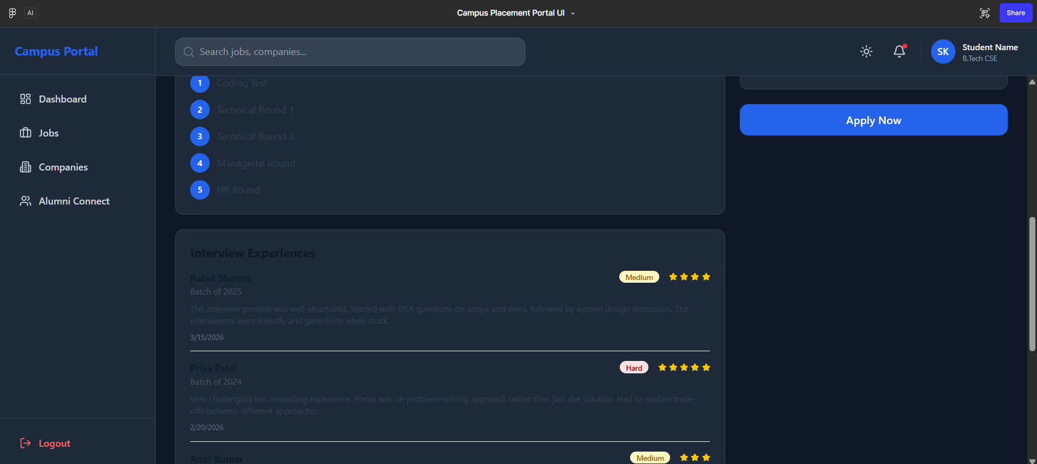
- 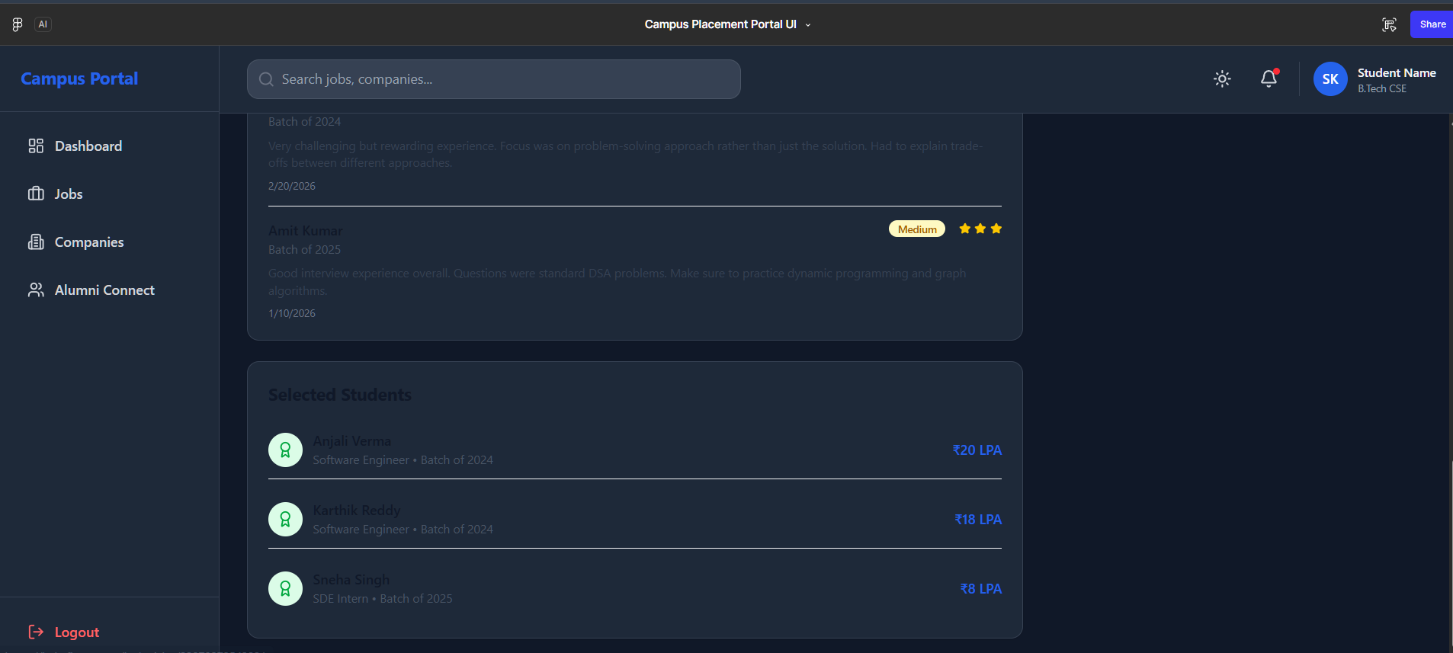

Alumni Connect:
- By default, there is a list of some students of the college or the top package got students from the college.
- There is a filter on this using that the student can filter out the senior students which were previously selected in the current student desired company to ask for help.
- On the basics of that filter the list of the already selected senior students gets refresh.
- Main Feature
  - Student can chat to any Senior he/ she wanted to.
  - Can call also
    - But before connect on call he needs to raise the call request from the button to schedule it
    - It is only possible only if the senior approves it other wise call button will be disable
    - Call button will be enabled only for the time period set by the senior.
    - By default, call button will be disable.
- 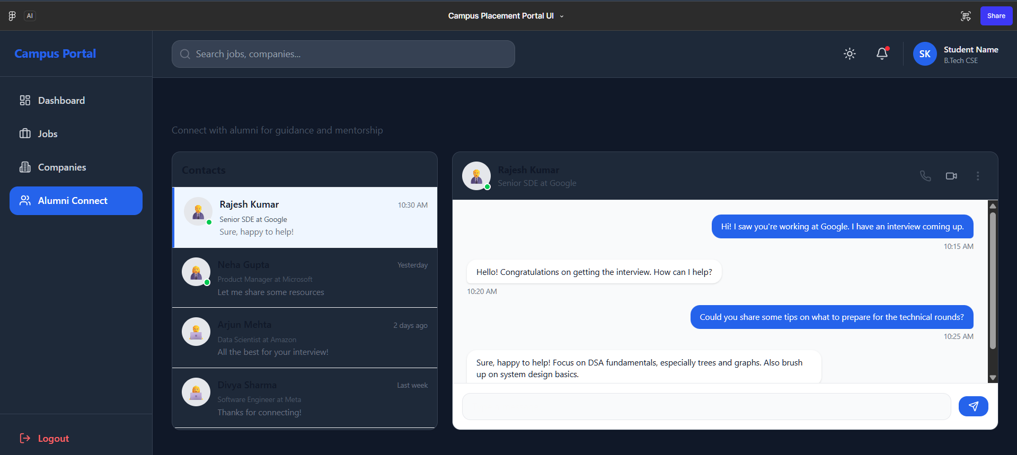
- 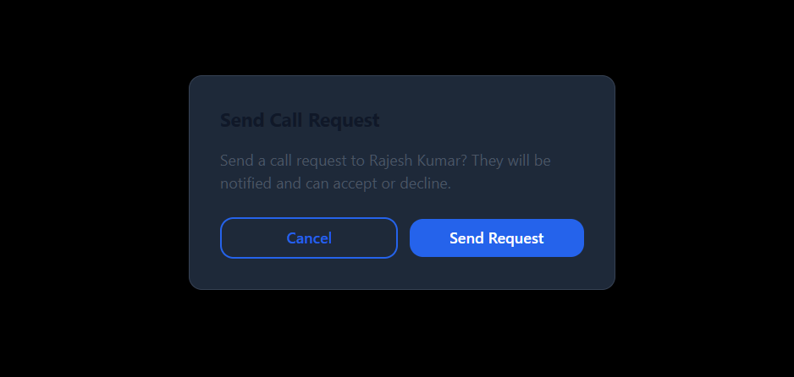

Prompt: less the 5000 characters:
Build a full-stack Placement Portal Web App (startup-level) using:

Frontend: Vite + Tailwind + Framer Motion (animations)
Backend: Node.js + Express
Database: PostgreSQL
Auth: JWT + OTP (email + phone)
Realtime: Socket.io (chat + notifications)

UI REQUIREMENTS:
- Modern SaaS UI, highly attractive, animated
- Dark mode toggle
- Responsive (mobile + desktop)
- Smooth transitions, hover effects, loaders
- Sidebar navigation

--------------------------------------------------

PROBLEM:
Students receive multiple placement forms via email and cannot track applications. Build a centralized portal for students + placement cell to manage everything.

--------------------------------------------------

ROLES:
1. Student
2. Admin (Placement Cell)

STRICT RULE:
Student cannot access admin APIs or pages.

--------------------------------------------------

AUTH:

STUDENT FIELDS:
- Name, Roll No
- College Email + Personal Email (OTP verified)
- Phone (OTP verified)
- 10th, 12th, CGPA
- Resume

ADMIN:
- Name
- College Email (OTP verified)
- Phone (OTP verified)

--------------------------------------------------

STUDENT FEATURES:

DASHBOARD:
- Profile summary
- Stats: Applied jobs, Eligible jobs, Upcoming drives
- Applied jobs list with STATUS BAR:
Applied → OA → Interview → Selected/Rejected
- Profile completeness % (missing fields highlighted)
- Notification bell (real-time)

--------------------------------------------------

JOBS PAGE:
- Job cards: company, role, package, location, JD, reviews
- Prioritize eligible jobs

FILTERS:
- Company, Role, Package, Location, Industry, Status

APPLY BUTTON:
- Enabled ONLY if eligible
- Else disabled with reason

--------------------------------------------------

ELIGIBILITY ENGINE:
Check:
- 10th, 12th %
- CGPA
- Branch
Return:
- eligible true/false + reason

--------------------------------------------------

JOB DETAIL PAGE:
- JD, rounds, eligibility, selection process
- Hiring process
- Interview experiences
- Selected students list

--------------------------------------------------

COMPANY PAGE:
- List companies (cards)
- Filters: industry, role, package

DETAIL PAGE:
- Past hiring data
- Interview experience
- Selection criteria
- Selected students

--------------------------------------------------

ALUMNI CONNECT:

- List of selected students (sorted by package)
- Student → chat (real-time)

CALL SYSTEM:
- Disabled by default
- Student sends request
- Alumni accepts → enables call for time slot

--------------------------------------------------

REVIEWS:
- Selected students can add interview experience & reviews

--------------------------------------------------

ADMIN FEATURES:

- Create/manage jobs:
- Company, roles, package, JD, location
- Eligibility rules (dynamic)
- Manage applications
- Update status (OA → Interview → Selected)

--------------------------------------------------

ADMIN ANALYTICS DASHBOARD:

- Total applicants per job
- Selection rate
- Branch-wise performance
- Company hiring trends
- Charts (bar, pie, line)

--------------------------------------------------

NOTIFICATIONS:
- In-app (real-time)
- Email alerts

--------------------------------------------------

SECURITY:
- JWT auth
- Role-based access
- Protected APIs
- Validation

--------------------------------------------------

EXTRA:
- Recommended jobs (based on profile)
- Alumni rating system (1–5 stars, top shown first)

--------------------------------------------------

DEMO LOGIN:
Student: divyansh@gmail.com / password
Admin: divyansh@admin.com / password

--------------------------------------------------

OUTPUT:
- Full frontend + backend code
- Clean structure
- APIs
- DB schema
- Production-ready app

Detail Feature Description for prompt:
I am thinking to build a startup product

Then problem statement which i want to solve

in college students who are in last year and when the placement derive is going on in the college they receive multiple company application form via mail from the college

So I am thinking to build a product like web portal to track and manage all the placement or form on which they have applied through the college.

And on the other hand placement cell can also manage all the record

Make sure ui and the whole navigation flow should be very much interactice and attractive to use

and there must a dark mode functional button also. make sure the whole web portal must the responsive and compatible with all screen sizes

Use Vite for front end

Now start with the main logic of the product

initially there will be a sexy and animated web page login page

which accept two roles:

1st is of student

2nd is for college admin or placement cell

here make sure student has not access of the admin portal, components, api's

now let's come to the required credentials to login

for student

1-Full name

2-roll number

3-personal email & college email (booth needs to be verified using otp)

4- phone number (this also otp verified)

5-10th, 12th, college gpa or result.

6-resume

7- resume

now for admin

1-name

2-college official admin email otp verified

3-Phone number otp verified

Now comes to the features which the student can access

1- At first there is a dashboard page of the student

-which includes the profile summary of the student

which includes

Applied job, elidgible job, upcoming drives in the campus

And a list of heading of applied jobs

which includes

all the jobs posts in which the student has applied

with the status bar on it like in a company there are multiple rounds

show the status of that accordingly which ever he/she clears or rejected accordingly

I have added the sample dashboard page take the reference of logic and features only on the ui

UI should be full of animations and must be very attractive

Now let's come to the job page

which includes all the job posting in the college

each company job posting is present in the form a card which includes all the job details like role, location, jd, salary, and the review of that company according to the students who has been already selected or working in that company.

Here comes the most important feature of the product

There must be a apply button the the job card

Which will only be enable it the student is eledigible for that particular job

and the eledgiblity criteria is set by the admin of the college

and if the student is not eledgible for that job then the apply button will be disable for him/her.

And there is also a filter feature on the job page like filter or sort according to location , pacakage, role , company, type of industry like mass heiring, big mnc, start up's fintech, edtech, finance, etc

I have also added the sample page for that and make sure do not create ui like that

noe lets come to the other page which is company page

here students is avle to see the multiple companies and each company is present in a form of card which includes the summary of company or rattings

And if the student clicks on any card which is company

then it includes all the past data like on previous year which company comes on which pacakage or role or interview rounds and the review which is provided by the already shortlisted student

and the most important thing in this page there is a list of students which has already been selected in that company form the college

And if the login student clicks on and selected student he navigate to the different page which is alumni connect page

in which the login student has a list of selected students with the badge of company in which they are selected in the sorted manner of pacakage got in the placement season.

and if the login student clicks on any selected student then he/she can chat with him to ask any doubt and there is also a voice and video call feature button which will be disable by disable by default

process the enable the voice/video call button

If the button was in disable state then the login student clicks then there will a call request sent to that particular person if he/she enables for any selected time the time and date can select by both the person but only if the selected person approves then only for that day or time period the button will work

and any student is selected in any company he/she can give the review or interview experience for that company on the portal which will later reflect on the portal to help the other students

Now lets come to the admin role

he can manage the job openings

create, deleted, set eledgiblity criteria for that job and what every the required field

And also have the full tract record no of students selected

which student is selected in which company

for now create login credential like

if student want to login he can login using sample email like divyansh@gmail.com

with random password

and for admin divyansh@admin.com

same with random password

And both has the profile section which displays all the profile details and if any thing they want to change like email or phone number they can do it but only otp verified

